Ocean Shores
Friends of the Library
Fall 2020 Newsletter
The FRIENDS OF THE LIBRARY [FOL] is an independent group dedicated to providing support and advocacy for our library.

Message from the President
Members,
I hope you are staying safe and not too stir-crazy. The Executive Committee held a socially distanced
meeting to discuss many issues. Under normal circumstances we would be holding our elections in
November, but we are not going to be able to have an in person meeting then. We unanimously voted
to extend all terms of office for one year. This is in keeping with the memberships that were all
extended to January of 2022. Please let me know if you have questions.
You probably know that FOL was the “round-it-up” nonprofit at Ace Hardware in August. We were
presented with a check from Ace for $6272.13! This is a fabulous program that Ace has, please consider rounding up for other monthly non-profits when you shop at Ace. - Malinda

FOL Bookstore Operation

The FOL Bookstore is open for you to shop with an appointment through the Library. Reservations (or walk in if space is available) are required. All shoppers must wear a mask and pass a temperature check. The library can currently only host 10 patrons at a time in the facility to maintain the governor's Covid requirements. Payments can be dropped in the "Honesty Boxes" in the meeting room. New items are added to the shelves weekly.

Over the last months FOL volunteers have offered days for people to donate items to the inventory. At this point we are planning to offer one day per month for patrons to drive up and make a donation. The November date has not been established but will be announced via Facebook and email once agreed upon.

Donated items include books in good condition (no mold, mildew, water or smoke damage), DVD's, CD's, Audio Books, Educational materials, and puzzles. We have also had a few plants donated over the last few months and they have been added to the store.

Your continued support is greatly appreciated. We do not have a plan to re-establish monthly book sales until we reach Phase 4 for the protection of our patrons and volunteers.

FOL Officers
President – Malinda Griffin
Vice President – Pam Clark
Treasurer – Mary Jo Lohrenz
Secretary – PJ Ford Slack
Member at Large (2 yr) – Judy Gow
Member at Large (2 yr) – Sharon Coone
Member at Large (1 yr) – Diane Durbin
Current Membership - 102

Little Free Library
Our Little Free Library was setup and established as an official Little Free Library May 5th of this year. So we are rather new at this. We have had quite a few visitors. One visitor inquired on how to set up her own Little Free Library. Another frequent visitor thanked us for providing this service. It has been a very rewarding experience.
Go to littlefreelibrary.org to set up your own Little Free Library or to find a map to find a registered Library near you.
Ours is located here: 574 Point Brown Ave SE
There are 3 other registered Little Free Libraries in OS: 152 Ocean Shores Blvd NW
Triangle Park Free Little Library
and
354 Canal Dr NE
Stay Healthy and Safe,
Pamela Clark

Did You Know?

Todd H. Bol created the first Little Free Library in 2009 in Hudson, Wisconsin, launching what would become a global book-sharing movement. Todd built the inaugural Little Free Library book exchange in honor of his mother, a schoolteacher and lifelong reader.

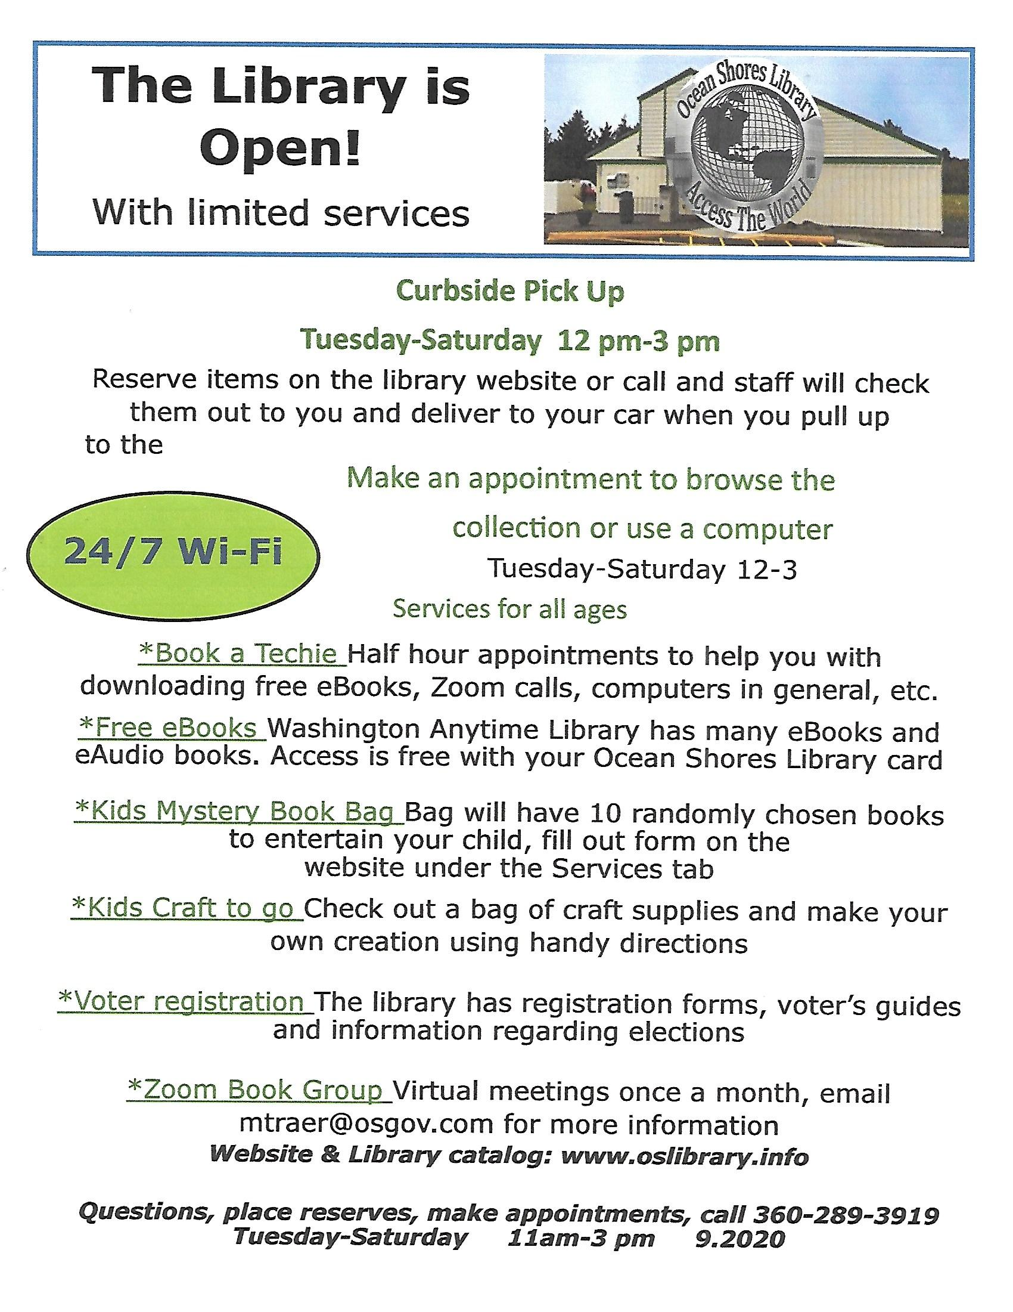

Here’s how some of our FOL members have been spending their time…….
“I have spent my time reading John Sanford novels and making face masks and matching aprons for my family and friends.”
- Diane Durbin

“It won’t be a surprise for most of you to hear that this retired librarian has done a lot of reading in this time of Covid. I usually read serious fiction, but do take a break periodically. I just added three books to my reading list, by Northwest author James Bierce. They make up the Grays Harbor Series, set in a post-apocalyptic time, about a family struggling to survive after a mysterious global catastrophe. Book 1: Westport, tells about a family from Portland, where people have either died mysteriously, or disappeared without a trace. Widespread panic leads them to look for safety in a remote cabin in Cohasset Beach, near Westport. In Book 1, I met zombies, so I can’t wait to find out what Book 2: Grayland, or Book 3: Aberdeen, will bring.
- Judy Gow
(Available in Kindle edition and in paperback on Amazon)

My time has been spent doing house projects such as tiling and deck building, gardening, and, of course, reading. So many good books – here is one of them:
“Wool” – by Hugh Howey
The first book in the acclaimed, New York Times best-selling trilogy, Wool is the story of mankind clawing for survival. The world outside has grown toxic, the view of it limited, talk of it forbidden. The remnants of humanity live underground in a single silo. But there are always those who hope, who dream. These are the dangerous people, the residents who infect others with their optimism. Their punishment is simple. They are given the very thing they want: They are allowed to go outside.
After the previous sheriff leaves the silo in a terrifying ritual, Juliette, a mechanic from the down deep, is suddenly and inexplicably promoted to the head of law enforcement. With newfound power and with little regard for the customs she is supposed to abide, Juliette uncovers hints of a sinister conspiracy. Tugging this thread may uncover the truth ... or it could kill every last human alive.
- Kathy Baker
(This, as well as the other books in the trilogy “Shift” and “Dust” are available at the Ocean Shores Library)

"Fast Girls: A Novel of the 1936 Women's Olympics" by Elise Hooper
If you enjoyed Dan Brown's "Boys in the Boat" you will want to read the story of the American Female Athletes from 1928- 1936 Olympics. This inspiring story is based on the real lives of three little-known trailblazing women Olympians.
In the 1928 Olympics, Chicago’s Betty Robinson competed as a member of the first-ever women’s delegation in track and field. Destined for further glory, she returns home feted as America’s Golden Girl until a nearly-fatal airplane crash threatens to end everything.
Outside of Boston, Louise Stokes, one of the few black girls in her town, sees competing as an opportunity to overcome the limitations placed on her. Eager to prove that she has what it takes to be a champion, she risks everything to join the Olympic team.
From Missouri, Helen Stephens, awkward, tomboyish, and poor, is considered an outcast by her schoolmates, but she dreams of escaping the hardships of her farm life through athletic success. Her aspirations appear impossible until a chance encounter changes her life.
These three athletes will join with others to defy society’s expectations of what women can achieve. As tensions bring the United States and Europe closer and closer to the brink of war, Betty, Louise, and Helen must fight for the chance to compete as the fastest women in the world amidst the pomp and pageantry of the Nazi-sponsored 1936 Olympics in Berlin.
- Mary Jo Lohrenz
This book is available at the Ocean Shores Library!

“Wool” – by Hugh Howey
“One of dystopian fiction’s masterpieces alongside the likes of 1984 and Brave New World."
—Daily Express
The first book in the acclaimed, New York Times best-selling trilogy, Wool is the story of mankind clawing for survival. The world outside has grown toxic, the view of it limited, talk of it forbidden. The remnants of humanity live underground in a single silo. But there are always those who hope, who dream. These are the dangerous people, the residents who infect others with their optimism. Their punishment is simple. They are given the very thing they want: They are allowed to go outside.
After the previous sheriff leaves the silo in a terrifying ritual, Juliette, a mechanic from the down deep, is suddenly and inexplicably promoted to the head of law enforcement. With newfound power and with little regard for the customs she is supposed to abide, Juliette uncovers hints of a sinister conspiracy. Tugging this thread may uncover the truth ... or it could kill every last human alive.
This, as well as the rest of the trilogy “Shift” and “Dust” are available at the Ocean Shores Library
(well, “Dust” will be available once I return it, that is!)
- Kathy Baker

News from the Library Board of Trustees-

News from the Board of Trustees
The Ocean Shores Library Board of Trustees (BOT) has resumed its monthly meetings by Zoom after a 4 month hiatus due to Covid 19. Public communication may be submitted to Sara Logan, City Clerk, by the date specified on the published agenda. The Board has worked closely with Director, Keitha Owen on the 2021-22 budget that she presented to the City Council.
The Board especially acknowledges Keitha and the staff during these challenging times for their creativity, service, and dedication in developing new ways to reach our patrons. OSL has been in the forefront of libraries nationwide. Thank you to our awesome staff. You truly are the heart of our community.
The Board of Trustees also thanks Katherine Baker for her year and a half of service. She contributed to the BOT with her positive insights, served as secretary, and shared her graphic and writing skills. While she will be missed on the BOT, the Foundation is grateful that she is remaining on its Board of Directors. Thanks—Kathy.
Denise Siers, President

I found this interesting (maybe you will, too) –
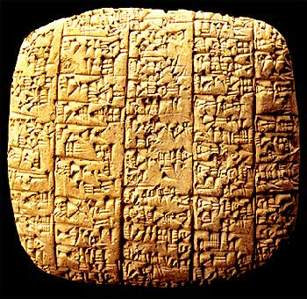 Photo source: Wikimedia Commons
When thinking of ancient libraries, most people assume that the Library of Alexandria was the oldest. It’s not (actually 4th oldest). The Royal Library of the ancient kingdom of Ebla, in Syria, is thought to be the oldest library in the world. Created between 2500 – 2250 BCE, Italian archaeologists have found about 2,000 complete tablets, 4,000 tablet fragments, and over 10,000 chips and small fragments. Unlike other ancient archives, there is evidence that suggests that the tablets from Ebla were purposefully arranged and even classified. Archaeologists were able to reconstruct the tablets’ original positions and discovered that they had been arranged by subject. Additionally, the tablets show evidence of the early transcription of texts into foreign languages and scripts, classification and cataloging for easier retrieval, and arrangement by size, form and content.

Photo source: Wikimedia Commons
Of course, this library is not still in operation. To find the oldest library in the world still in operation, we would have to go to Saint Catherine’s Monastery, located at the foot of the legendary Mount Sinai. Created between 548 – 565 CE, this library is also considered one of the oldest functioning monasteries in the world, and contains the second largest collection of ancient manuscripts and codices, just after Vatican City. The library houses several unique and important texts, including the Syriac Sinaiticus and, until 1859, the Codex Sinaiticus, the oldest known complete Bible dating back to around 345 CE.

